


International Student Handbook

2026

Message from CEO

Ray Fa
Chief Executive Officer
(signature)

About AHEI
Alliance Higher Education Institute (AHEI) is established under the Alliance Higher Education Institute Constitution (July 2024) and intends to be registered on the Tertiary Education Quality and Standards Agency (TEQSA) National Register as a registered provider of higher education, and on the Commonwealth Register of Institutions and Courses for Overseas Students (CRICOS) as a provider of education to international students in 2026.
The AHEI Governance Framework outlines the Institute’s commitment to principles of good governance in accordance with best practice and requirements of the Corporations Act 2001, Higher Education Standards Framework (Threshold Standards) 2021 (HESF) and Education Services for Overseas Students Act 2000 (ESOS Act).
Commonly owned registered training organisations, Alliance College (RTO 0137) and Concord Institute (RTO 45434) are committed to enhancing their current vocational educational offerings by providing access to further tertiary education to learners, and provision of quality course offerings within the Australian non-university higher education sector. AHEI has its foundations in Alliance College (RTO 0137 | CRICOS 01774A), formerly the Adelaide Hospitality and Tourism School, established in Adelaide in 1981.
With over 44 years of experience, Alliance has evolved into a leading provider of vocational training in trades aligned to national skills demand. In 2023, the group expanded through the acquisition of Adelaide Education and Training Pty Ltd (T/A Concord Institute, RTO 45434 | CRICOS 03970C), which focuses on allied health training.
AHEI will operate with its own independent governance and academic structures to ensure higher education programs are developed and delivered independently, and free from operational or academic influence from the VET brands. AHEI maintains a clear separation between its higher education operations and those of the vocational education providers through a distinct governance framework.
The Institute is governed by a separate Corporate Board and an Academic Board with delegated authority over all academic matters, including course development, quality assurance, and academic integrity. The Academic Board operates independently, with members selected for their higher education expertise, and reports directly to the Corporate Board. Key academic policies, procedures, and decision-making processes are unique to AHEI and are not shared with the vocational entities
AHEI carves a distinct niche in international education, characterised by a commitment to academic rigor, inclusivity, community engagement and industry collaboration. Our current vocational student body comprises individuals from more than 50 cultural backgrounds, and a workforce across both RTOs originating from more than 15 countries.
With a forward-thinking approach to curriculum design and pedagogy, AHEI will strive to equip our graduates with the skills, knowledge, and mindset necessary to thrive in an ever-evolving global landscape. Our commitment to fostering a culture of innovation and entrepreneurship will set us apart from our competition, empowering students to become agents of change in their respective fields.

About Us:
Alliance Higher Education Institute (AHEI) (pending TEQSA accreditation) is committed to delivering high-quality academic programs underpinned by applied learning and industry engagement. AHEI was founded by experienced leaders in vocational and higher education with a shared commitment to student success and educational excellence. Our academic offerings are designed to develop graduates who demonstrate professional competence, critical thinking, and a strong sense of ethical and social responsibility.
The Institute upholds the principles and standards set out in the Higher Education Standards Framework (Threshold Standards) 2021 and operates in accordance with the Education Services for Overseas Students (ESOS) Framework. Our governance and quality assurance systems ensure that all courses, teaching, and support services meet the expectations of both regulatory authorities and the broader higher education community.
AHEI maintains close links with industry and professional sectors to ensure that learning outcomes align with current and emerging workforce needs. Our focus on applied learning provides students with meaningful opportunities to connect theory with practice in real-world contexts.
Through a culture of continuous improvement, academic integrity, and student-centred practice, AHEI strives to contribute to the advancement of knowledge and to the preparation of capable graduates equipped to make a positive contribution within Australia and internationally.
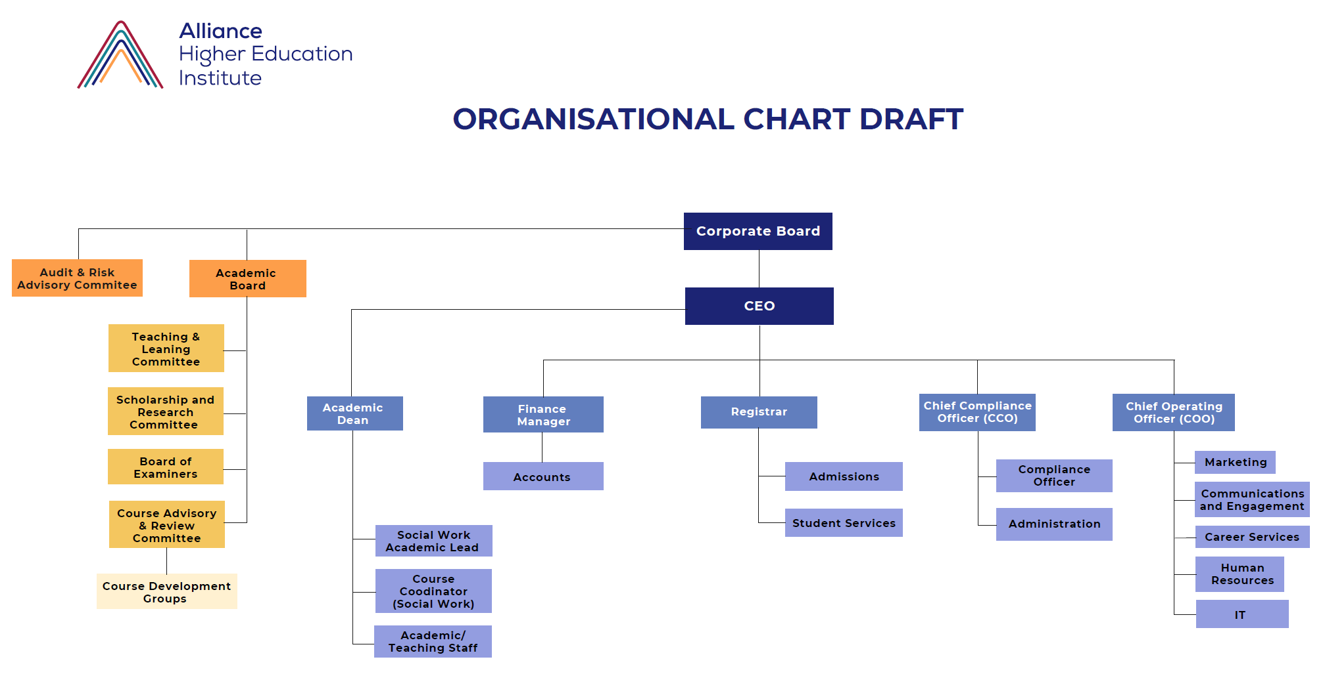

AHEI Contact Details:
Campus Address: Level 1/115 Grenfell Street, Adelaide, South Australia, 5000, Australia
T: 1800 567 890 email: ahei@ahei.edu.au W: www.ahei.edu.au
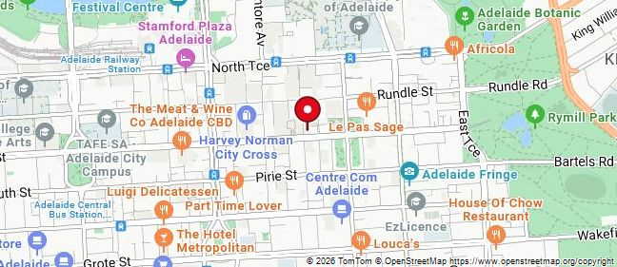
AHEI Campus:
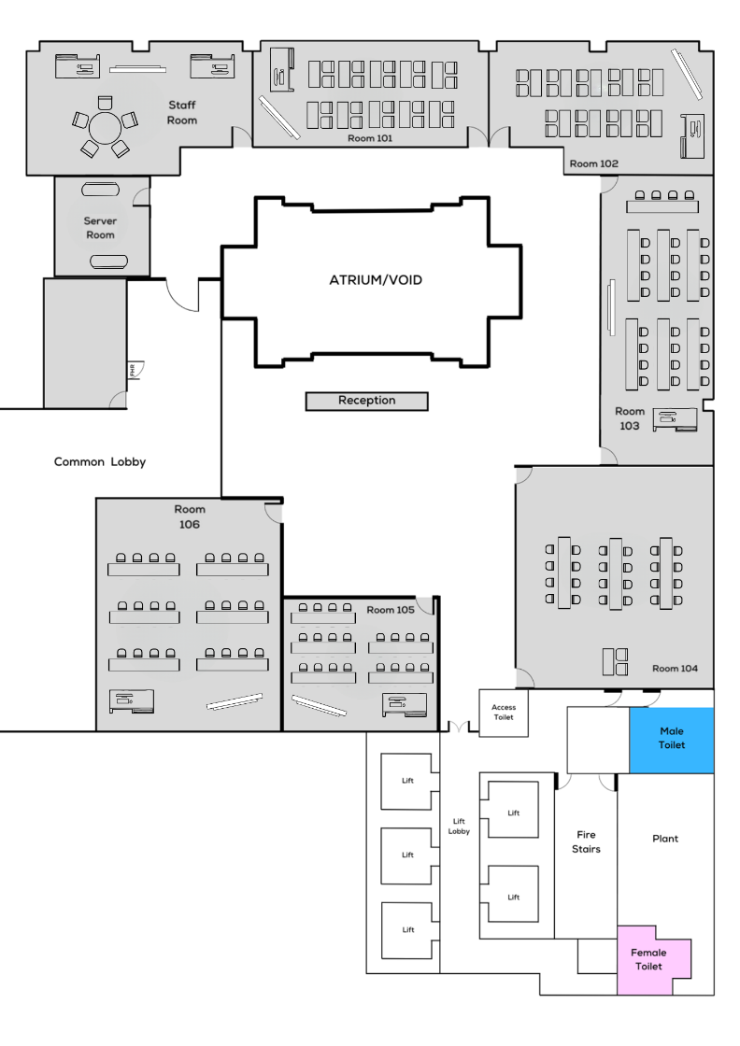

Emergency Telephone Numbers: Police, Fire, Ambulance – 000
Department of Home Affairs: 9 Wentworth Street, Parramatta, NSW 2150 Ph.: 131 881 Opening Hours: 9 am to 4 pm - Monday to Friday
Medical Centres:
Vitality Health Care Medical Centre - Vitality Healthcare Medical Centre - Adelaide GP Services Bulk Bill Concessions & Kids under 16
Adelaide City General Practice - https://www.acgp.com.au/
Mental Health Services in Adelaide:
Adelaide offers a range of mental health services to support individuals and families in need. Here are some key services available:
- SA Health Mental Triage Service: Provides advice and information in mental health emergencies or crises.
- Urgent Mental Health Care Centre (UMHCC): A free service for anyone experiencing a mental health crisis, open 24/7.
- Lifeline: A national charity offering 24/7 crisis support and suicide prevention services.
- Kids Helpline: A free, confidential service for young people aged 5 to 25.
- 13YARN: A service for Aboriginal and Torres Strait Islander people experiencing crisis.
- 1800RESPECT: A national domestic violence and sexual violence counselling service.
These services are designed to provide immediate support and resources to those in need, ensuring they can access the help they require. For more information or to access these services, individuals can contact the respective helplines or visit the locations mentioned above.
Transport: In Adelaide, you have several transport options:
Public Transport: Operated by Adelaide Metro, it includes buses, trains, and trams. The free City Connector bus and tram services are convenient for getting around the city center.
Bike-Sharing: For those looking for an active adventure, bike-sharing services are available.
Walking: Adelaide is pedestrian-friendly, making it easy to explore on foot.
Boat Tours: For a leisurely sightseeing experience, consider taking a boat tour.
Special Services: During festivals, special transport services may operate to accommodate visitors.
These options make it easy to navigate the city and its surroundings.
Public facilities: Banks and ATM’s are located in Rundle Mall - Rundle Mall • Banks.

Course(s)
The AHEI Bachelor of Social Work (BSW) course is designed to meet the Australian Qualifications Framework (AQF) Level 7 standards and the Australian Association of Social Workers (AASW) Accreditation Standards for Social Work Education (AASW, ASWEAS 2024).
The curriculum integrates academic rigour, practical skills development, and a strong emphasis on reflective and ethical practice.
The BSW is a distinctive, professionally focused course that aligns with national standards while offering strong features to support student success. Its emphasis on cultural responsiveness, immersive field education, and structured professional preparation positions it as a competitive and accessible offering.
By prioritising ethical practice, workforce readiness, and reflective learning, the course equips graduates to make meaningful contributions to the social work profession and the communities they serve.
The BSW curriculum spans four years of full-time study (or part-time equivalent), comprising 320 credit points (cps) organised across 29 units. Each unit carries a weight of 10 cps, except for one capstone unit and two field education (placement) units of 20 credit points each.
The course is delivered across academic semesters, offering students a balanced workload of 40 credit points per semester.
The AHEI BSW is offered on-campus and online in blended delivery mode, integrating in-person learning with the flexibility of online synchronous and asynchronous learning.
Code: BSW123
Bachelor of Social Work (BSW)
Intake for 2027 is 25 students at the Grenfell Street campus only.
Admissions Criteria
Academic
General Entry - Certificate IV completion minimum in an Australian Vocational Education Training (VET) course.
School Leavers - No ATAR score required. Applicants need to provide evidence of completions of their Year 12 Senior Secondary Certificate of Education and satisfactory completion to 50% minimum score in most subjects.
English Language
Satisfactory completion of Year 12, or equivalent in English or one of the following:
Studying English at an Australian English Language College: Successful completion of an English for Academic Purpose (EAP) course at an Australian College of English or another approved English Language College is accepted as a proof of English Language proficiency.

Academic IELTS: 7.0 with no skills band less than 7.0
Test of English as a Foreign Language (TOEFL): 80
Pearson Test of English (PTE) Academic (PTE-A): 65
Cambridge English Scale Score (after 2015): 185
‘Duolingo’ and ‘EF Set’ English language tests are not accepted because they are not accepted by the Australian Immigration, AASW or major universities for social work and related disciplines.
Special Consideration
Applicants in any category whose study, work or life experiences have been impacted by disability, illness or family disruption may be given special consideration for admission. Each application will be considered on its merit, based on the evidence supplied by the applicant attesting to the circumstances of the applicant.
Minimum academic entry standards apply to all students, but individual students can apply for an English Language (EL) requirement waiver under the AHEI policy and procedure. There are three (3) categories for waivers:

Applicant is from a non-English speaking country and has completed a Secondary School Education which has been taught and assessed in English: Applicants can satisfy the EL requirement with successful completion of one of the secondary school English subjects/courses listed, which must have been completed within the last 2 years.

Applicant has undertaken Tertiary (VET) or Higher Education Studies taught and assessed entirely in English. A transcript of completion and a letter certifying that the course was taught and assessed in English will be required.

Work Experience of four or more years in full-time employment (in a community services, allied health, or human services context) where the language of employment is English. Note, evidence of proficiency in written and verbal English language from employers is required evidence.
Contact the Admissions Officer to apply for a waiver as part of your application.
Pathways and Credit for Diploma of Community Services
Students graduating with the following Australian VET qualifications can apply for direct entry into the Bachelor of Social Work with credits:
CHC52021 Diploma of Community Services (Case Management) (Social Housing) (Child Youth & Family Welfare) (Responding to Family Violence).
CHC50421 Diploma of Youth Work
CHC553315 Diploma of Mental Health.
These students can apply for credit for up to ten (10) units of study from Year 1 and Year 2 of the Bachelor of Social Work course on submission of a certified completed Statement of Competency.

Application Process
Prospective students apply online using the AHEI BSW Application Form. All applicants should make an appointment with the BSW Admissions Officer for an interview.
Applications are considered within 14 days of being submitted and applicants are contacted if more information is required. Successful applicants will be notified via email as soon as their application has been deemed meeting all the criteria by the selection panel.
Bachelor of Social Work Course Structure
The following is the structure of the AHEI 4-year BSW (AQF) of 320 credit points.
Unit Code | Semester | Unit Name | Unit Type | Credit Points | Delivery Mode
Year 1 – Foundation Studies
ACS101 | 1 | Academic Skills | Core | 10 | Blended
COM101 | 1 | Interpersonal Communication | Core | 10 | On campus
SOC101 | 1 | Introduction to Sociology – Understanding Society | Core | 10 | Blended
SOC102 | 1 | Human Behaviour in a Social Context | Core | 10 | On campus
SOC103 | 2 | Introduction to Social Work | Core | 10 | On campus
SOC104 | 2 | Australian Society and Social Policy | Core | 10 | Blended
SOC105 | 2 | Australian Indigenous Perspectives | Core | 10 | Online
SOC106 | 2 | Human Lifespan Development | Core | 10 | Online
Year 2 - Beginning Practices
SOC201 | 3 | Social Work Theories and Practice Frameworks | Core | 10 | On campus
SOC202 | 3 | Working with Diverse Populations | Core | 10 | On campus
SOC203 | 3 | Working with Children and Families | Core | 10 | On campus
SOC204 | 3 | Mental Health in the Community | Core | 10 | Blended
SOC205 | 4 | Legal, Ethical and Social Policy Frameworks | Core | 10 | Online
SOC206 | 4 | Disability: Strategies, Interventions and Service Standards | Core | 10 | On campus
SOC207 | 4 | Preparing for Practice in the Field: Simulated Practice Activities | Core | 10 | Blended
SOC208 | 4 | Family Violence Practices | Core | 10 | On campus
Year 3 – Essential Practices
SOC302 | 5 | Casework and Counselling in Social Work | Core | 10 | On campus
SOC301 | 5 | Group and Community Development Processes and Practices | Core | 10 | On campus
SOC303 | 5 | Social Work and Health | Core | 10 | Blended
SOC304 | 5 | Community Management and Human Service Organisations | Core | 10 | Online
SOC305 | 6 | Evidence-Based Social Work Practices | Core | 10 | Online
SOC306 | 6 | Social Policy Analysis and Advocacy | Core | 10 | Online
SOC307 | 6 | Professional Skills Development A (500-hour Placement) | Core | 20 | In agency
Year 4 – Graduate Practices
SOC401 | 7 | Statutory Social Work: Working with Victims and Offenders | Core | 10 | On campus
SOC402 | 7 | Innovation in Social Policy and Research: Evidence based Practice | Core | 10 | Blended
SOC403 | 7 | Trauma-informed Social Work Practices | Core | 10 | On campus
SOC404 | 7 | Contemporary International Issues in Social Work | Core | 10 | Blended
SOC405 | 8 | Professional and Ethical Decision-Making in Social Work | Core | 10 | Blended
SOC406 | 8 | Social Work Research | Core | 10 | Online
SOC407 | 8 | Professional Skills Development B (500 hours Placement) | Core | 20 | In agency
Total of 320 cps = 4,820 course hours
*Note 1 credit point = 13.5 hours of delivery and self-directed learning per unit of study.
10 credit point units of study = 135 hours per unit of study per semester or 11.25 hours per unit of study per week.
Assessments
The BSW is mixed delivery with online recorded lectures (knowledge & theories) and 3-hour block workshops weekly for skills development (practice frameworks) that engage students in being active in their learning by connecting to academic texts and government and community-based frameworks and services in real world scenarios.
The assessments in the BSW are significant and complex in that they need to ensure the development of academic skills, access to theoretical and discipline-based knowledge and allow students to demonstrate the community services practice skills required for staff to be able to assess that students are becoming practice-ready for field education placements and as graduates.
The assessment processes include a comprehensive feedback loop for students that ensures that they receive feedback on their academic, knowledge and practice skills development and any deficiencies that need to be worked on.
There are three (3) main assessments per unit of study. Some units of study contain hurdle or non-graded items that aim to scaffold complex learning around theory and practices.

Placements
There are two (2) units for social work practice placement, one at the end of 3rd year and one at the end of 4th year with on campus preparation for placement workshops and on campus placement integration workshops.
Social work offers a wide range of career options and specializations and as such placement could be in any of the following fields of practice.:
- Community work – social work alongside groups, organizations and individuals to assess the needs of a population, plan and administer programs, and connect communities with resources.
- Child and Family Services – social work in teams to work with families in their communities to create well-being and safety for women and children.
- Health Services - collaborating with larger medical teams to develop an overall care plan for patients, provide mental and emotional support to patients and their families, and connect patients to resources they may need within the health care system.
- Mental Health Services - supporting clients who have mental health disorders or substance misuse issues through a range of interventions such as therapy.
- Social work with military personnel – assisting military service members, veterans and their families with the unique challenges associated with military life, which can include everything from mental health challenges to transitioning back to civilian life.
- Education and Schools - empower students to reach their full potential by providing evidence-based interventions to improve academic performance and behavioural outcomes.
- Social work management - work at a macro level, steering the direction of organisations committed to fulfilling the needs of various populations.
- Government services – work with people experiencing unemployment, sickness and disability, people needing aged care.
- Prisons and community corrections – working in the justice system to assist people to reintegrate into communities following imprisonment or other sentencing.

Dates and Deadlines
AHEI Admissions Calendar 2027
Admissions Task | Timelines | Key contacts
Applications submitted online | 1 January 2027 – 23 June 2027 | BSW Admissions Officer
Selection Panel | Ongoing – applications considered once submitted | BSW Admissions Officer  BSW Course Coordinator
COEs Issue | Ongoing – COEs offered once an application is accepted | BSW Admissions Officer
Enrolment | Online from 3 March 2027 –  4 July 2027 | Registrar
Orientation | Week of 6-9 July 2027 | BSW Course Coordinator
Semester Commences | 12 July 2027 | BSW Course Coordinator

Census dates for enrolment 2027 and 2028 (TBC)

Academic Calendar 2027 – 2028 & 2028 – 2029 (TBC)

Scholarships
AHEI offers…
FUTURE STUDENTS – AHEI

Fees and Charges
Bachelor of Social Work 2027-2028
International student total course fee ($) | $ 98,000
International student course fee ($) per year | $ 24,500
There are no other fees or charges for international students to study at AHEI.

Orientation, Rules and Governance
Orientation
Student orientation at all campuses is conducted in the first week of each new intake (course commencement). Arriving early to attend orientation gives you the chance to see and talk to the most important people you will need to know at the institution.
» Campus Manager
» Course Coordinator
» Lecturers
» English Language Educators
» Student Support
» Student Administration and Support Officers
» Learning Support Officers.
Enrol early which will help you to get your student card early. You will need your student card to open bank accounts, borrow books from the library, and more.
Meet and get advice from your Academic and Course Advisor. Meet representatives of Student Associations, Clubs, and Mentors. Find your way around the campus
» Library
» Computer rooms and facilities
» Recreation and eating areas
» Classrooms
Students Rights and Responsibilities
All relevant AHEI Policies and Procedures for students are on the website for viewing. If you need any advice or assistance, please contact Student Support Services.
CURRENT STUDENTS – AHEI
Student ‘Code of Conduct’
Students are required to always adhere to AHEI Student Code of Conduct. A copy of AHEI’s policy on ‘Student Code of Behaviour’ is available from the AHEI website.
Academic Policies and Procedures
AHEI’s academic policies and procedures are accessible from the AHEI website, under the ‘About’ tab as ‘Our Policies and Procedures’. Please contact our administration staff or your course coordinator.

Complaints and Appeals
AHEI takes complaints very seriously and respects the right of students to appeal decisions that are made during academic and administrative procedures. The Student Complaints and Appeals Policy and Procedure set out the procedures and principles that govern how your complaint will be handled.
AHEI staff will endeavour to address your needs if they are brought to their attention, so it is recommended that you discuss your complaint or grievance with a Student Support Staff, if you feel comfortable doing so. At the very least, they can give you information about how to have your complaint heard. You will not be disadvantaged, provided your complaint is not knowingly false or vexatious. Complaints help us to improve our services.
Informal Complaints Process - Students are encouraged to resolve complaints informally with the Lecturer/ Student Support staff before making a formal complaint. If not satisfied students are further encouraged to speak to the Course Coordinator of their enrolled course and present their complaint. The Course Coordinator will try and resolve the issue and come to a satisfactory solution.
Formal Complaints Process - Students can access the ‘Student Complaint Register through the student portal or complete the ‘Complaints and Grievances Form’ on the website. The Complaint will be recorded in the Student Complaints Register, in the ‘Student Management System’ and ‘Student Profile’.
AHEI will investigate the complaint and provide a resolution. This resolution will be reviewed by the Academic team for opportunities for continuous improvement. During the investigation, the complainant will be given an opportunity to formally present their case and have the option of being accompanied/ assisted by a nominee (such as a family member, friend or counsellor) if they so desire. If the students are using a paid nominee, it will be at their own cost. The nominee must present their photo ID while accompanying the student at any of the appointments at AHEI.
The students are informed of the outcome of the complaint which will be recorded in the student portal. Students may use the Formal Appeals Process if they are not satisfied with the outcome of the complaint resolution process. If the student is dissatisfied with the resolution proposed by AHEI, we can refer students to an independent mediator at the Student Mediation Scheme.
Formal Appeals Process - Students can access the ‘Student Complaint Register through the student portal or complete the ‘Complaints and Grievances Form’ on the website. A paper form is available at the campus. The Appeal is recorded in Student Complaints and Appeal in the Student management system and Student Profile. AHEI will convene a panel (someone more senior and not previously involved in the case added to the panel for appeals) that will investigate the appeal and decide.
The student will be given an opportunity to formally present their case to the panel and have the option of being accompanied/ assisted by a nominee (such as a family member, friend or counsellor) if they so desire. The student is informed by email of the outcome of the appeal and will be recorded in the student portal. If the student is dissatisfied with the appeals process by AHEI, they can access the provision of an independent mediator; Student Mediation Scheme provided by Resolution Institute at no cost to the student.

For international students, if not satisfied, students may take up the complaint with “Ombudsman”. Ombudsman Complaints about AHEI administrative actions and decisions can be made to the applicable state Ombudsman (S.A.) no cost. If students have not followed the steps in these guidelines, the Ombudsman may ask that they do so before accepting their complaints.
Timeframes – AHEI considers complaints and grievances in a timely manner, the acknowledgement of receipt of complaint will be sent within five (5) working days and the outcome of the complaint/appeal must be sent to the student within thirty (30) working days from the initial response. Record Management at AHEI will maintain records of all complaints and appeals from the students and the assessment of, and decision, for 2 years.
Academic Progress
Students are obligated to uphold their commitment to maintaining satisfactory course progress by successfully completing a minimum of 50% of the units scheduled for each study period. It is essential to engage proactively with your Course Coordinator, lecturers and student support services to help you achieve and maintain satisfactory course progress throughout your studies. By doing so, you can avoid potential academic challenges and enjoy a successful educational experience.
Support for student at-risk - A student who is concerned about his or her progress in the course is encouraged to contact the lecturer, Course Coordinator or and Student Support Services to seek assistance. AHEI will offer support and give the student an opportunity to meet the performance and/or progression expectations. Our goal is to work closely with at-risk students to address their specific challenges and help them get back on track.
This may involve academic support, counselling, or referrals to relevant support services. We believe that early intervention and personalised support are key to helping students overcome difficulties and succeed in their studies.

AHEI Schools and Departments
To be populated once Schools & Depts are formed.

School of Society & Culture

Student Administration

Key Staff
CEO | Mr Ben Mayne
Academic Dean | Professor Rob Townsend
Social Work Academic Lead / Head of School | Ms Tara Lees
Social Work Educators | Ms Cris Bruno  Ms TJ Kaur  Ms Liesl Krebs
Registrar (Student Admin) | TBC
Academic Learning Support | TBC
Student Support Officers | TBC
Counselling (Student Wellbeing) | TBC
IT Support | TBC

Living in Australia
Australia is a land of diversity and culture. Living in a new country can be very different and your lifestyle is likely to change. To help you adapt to Australia specifically, we have compiled resources detailing what life in Australia is like:

Map and Climate
For international students from Europe and North America, the climate in Australia may take some getting used to, as the Australian seasons are opposite to those in Europe and North America. The climate in Australia varies widely depending on the area, as Australia consists of a variety of environments: from beaches to deserts to grazing lands to coral reefs.

People and Culture
Australia is an extremely culturally diverse country. It is varied in its religion, language, history, and art.
International students who study in Australia will find themselves studying in a fascinating and diverse environment.

Accommodation
One of the first things international students will have to determine when preparing to study in Australia is where to live. Most Australian students live off campus through homestay programs, in hostels, or rental properties. However, some Australian universities provide housing options, which allows international students to socialize with local students.

Getting Around
Australia is an extremely large country, making transportation very important. The public transportation system is very efficient, and international students should always be able to get to where they need to go, whether by bus, train, rideshare, bike, or plane.

Money Matters
Tuition in Australia is generally less expensive than tuition in other countries like the United States or United Kingdom, but it is still important for international students to budget and be careful with their finances.

Health Care in Australia
International students who are planning to study in Australia should first familiarize themselves with the country’s healthcare system. It is important to be aware of the quality and workings of the healthcare available to you, should the unexpected happen.
Healthcare availability in Australia has been steadily improving. Life expectancy for men and women have some of the highest rates among developed countries. Infant mortality in Australia is also low. The most common health concerns in Australia are skin cancer, heat stroke, obesity, diabetes, dengue fever, and other chronic diseases common to developed countries.

Universal Health Care in Australia
Australia achieves universal health coverage through Medicare, which was founded in 1984. Medicare is a tax-funded public insurance program that covers most medical care, such as physician and hospital services and prescription drugs. Its purpose is to provide affordable, high quality health care for all Australian residents, regardless of their circumstances. Medicare subsidizes services and prescription medications from pharmacies, provides free treatment in public hospitals, and provides free or subsidized payments to health professionals for specific services.

Private Health Insurance in Australia
Roughly half of Australian citizens receive additional insurance coverage through private insurance, subsidized by the government. This covers services such as dental care and private hospitals. Private health insurance represents about 11% of health care funding in Australia. It allows patients to have a wider choice of doctors and hospitals, and to choose the timing of a procedure. Private health insurance can be used in private hospitals, or by patients in public hospitals who wish to be treated as private patients. It also covers some medical services not covered by Medicare, such as optical, physiotherapy, podiatry, and dental services. The Australian government provides a subsidy equivalent to 30% of the insurance premiums for those who are subscribed to private health insurance and facilitates payment of reduced premiums to health funds or directly to contributors as alternative payments.

Pharmaceutical Benefits Scheme
Australia’s Pharmaceutical Benefits Scheme (PBS) is a publicly funded, comprehensive program that reimburses pharmacists for the costs of dispensing prescribed medicines. It does this in accordance with a comprehensive national formula. The PBS operates under Australia’s National Medicines Policy and is a vital part of Medicare. Its objective is “to provide timely access to the medicines that Australians need, at a cost individuals and the community can afford.” The PBS is available to all Australians, as well as international guests from countries that have a reciprocal health care agreement with Australia.

Health Care for International Visitors in Australia
Medicare benefits are available to visitors coming to Australia from countries that have a reciprocal healthcare agreement with Australia. These countries include the United Kingdom, the Republic of Ireland, New Zealand, Sweden, the Netherlands, Finland, Belgium, Norway, Slovenia, Malta, and Italy. The length of your coverage depends on where you are visiting from.

Residents of New Zealand, the United Kingdom, the Republic of Ireland, Sweden, Finland, or Norway are covered for the entire length of their stay. Residents of Belgium, the Netherlands, or Slovenia are covered until the expiration date on their European Health Insurance card, or until the end of their stay in Australia, whichever comes first. Residents of Malta or Italy are covered by Medicare for six months following the date of their arrival in Australia.
If you are not from any of these countries, you can inquire about comprehensive private health insurance to cover your stay in Australia.

Health Care for International Students in Australia
Visitors in Australia under a student visa (except for students from Belgium, New Zealand, Norway, and Sweden) are required to purchase Overseas Student Health Cover (OSHC) during their stay. If you are in Australia on a student visa from the United Kingdom, Sweden, the Netherlands, Belgium, Slovenia, Italy, or New Zealand, you are covered by Medicare.
Students visiting Australia from Norway, Finland, Malta, and the Republic of Ireland are not covered by their country’s reciprocal healthcare agreement with Australia.
Working in Australia
Working in Australia is very easy to do while you are a student – after graduation, it's more difficult. Remember, as an international student, you should never expect to live on the money you make while studying, but the extra income can certainly help you meet your financial needs.
Student Visa Rules
Learn the rules governing how much you can work while studying in Australia. As a general rule, students can work for up to 20 hours per week while school is in session, and full-time during semester breaks.
Student Visa Rules | Study in Australia
Work Permission and Other Practicalities
Find out about receiving permission to work, obtaining a tax file number, opening a bank account, etc. - all the practicalities you need to start earning that paycheck.
Work Permission and Other Practicalities | Study in Australia
Getting a Job
Get practical advice on landing a job in Australia, including the kinds of jobs you can expect to get, potential wages, where to look for jobs, and how to maintain your best foot forward when you do land a job.
Getting a Job | Study in Australia
After Graduation
After graduation, many international students want to stay in Australia and work. Check out this useful information.
Working After Graduation | Study in Australia

Religion
Although Australia is a predominantly Christian country with about 52% of all Australians identifying as Christian, there is no official state religion. People in Australia are free to practice any religion they choose, if they are not breaking the law. Religions from all over the world are practiced in Australia, demonstrating its cultural diversity.
Most universities and communities in Australia have facilities and places of worship for all types of faith, so international students in Australia should contact their international student officer about facilities at their educational institution.
Language
Australia has no official language, but most of the population speaks English as a first language. According to the 2016 census, 73% of people in Australia spoke only English at home, even including many first- and second-generation migrants. Australian English has a distinctive accent and vocabulary. Because people from about 200 countries around the world have migrated to Australia, there is a vast collection of languages spoken in the country.
Other languages spoken in Australia include Mandarin, Italian, Arabic, Cantonese, and Greek. It is believed that at one time, there were almost 400 Australian Aboriginal languages, but now only 70 of these languages have survived, and all but 30 are endangered.
One indigenous language is still the main language for about 50,000 Aboriginal people in Australia.
Indigenous Australians
Indigenous Australians, or Aboriginals, are the original inhabitants of Australia. They migrated from Africa to Asia around 70,000 years ago, and from Asia to Australia 40,000 to 50,000 years ago. When the British arrived and began to settle in Australia, they brought with them diseases such as measles, smallpox, and tuberculosis, causing massive amounts of damage to the Aboriginal population. The British also appropriated land and water resources in Australia and converted rural lands for sheep and cattle grazing.
There is a great amount of diversity between different Indigenous communities and societies in Australia. Each has its own customs, cultures, and languages. The Indigenous Australian population is mostly urbanized, but as of 2017, 22% live in remote settlements. These settlements are often located on the site of former church missions.
Australian Art
Australian art dates to prehistoric times. It includes Indigenous, Colonial, Landscape, Atelier, early twentieth century painters, printmakers, photographers, sculptors, and contemporary art. Art in Australia has a long history. There is evidence of Aboriginal art that dates back at least 30,000 years.
Examples of Aboriginal rock artwork can be found throughout the continent. Australia has produced many notable artists of both Western and Indigenous Australian schools throughout the course of its long and impressive history. Australia has many major art museums and galleries, both supported by the national, state, and local government, and by university and privately owned museums.

Adelaide, South Australia
Compared to other major Australian cities, Adelaide offers more value for your money, more career opportunities and a safer, more supportive environment.
Study in Adelaide with students from all over the world.
You'll love the lifestyle in Adelaide. The friendly people and strong community will help you feel at home.
Once you finish your studies, kickstart your career within one of many innovative, world-leading employers that call Adelaide home.
- 9th most liveable city in the world*
- Rent is 47% lower than Sydney, 8% lower than Melbourne, 20% lower than Perth^
- Universities ranked in the top 2%
Adelaide’s strong ties between industry and education create many job opportunities, from internships and part-time work to graduate and entry-level roles.
Future-focused educational institutions will enable you to forge industry connections with employers, while developing practical, real-world skills that will help you succeed in your dream job.
Study Adelaide website
https://studyadelaide.com/



AHEI Assist and Contacts
Student Administration:
Student Support Services:
IT Services:
Campus:
Course Coordinator:
To be populated when contact details are available.

Document Control
Status and Details
Status | Current
Policy Category | Academic
Effective date: | 1 January 2026
Review date | 2028
Approval authority | Academic Board
Approval date | November 2025
Responsible Officer | Academic Dean
Version History
Version | Date | Notes
1.0 | October 2025 | Devised by Academic Dean
1.1 | January 2026 | Revised by Academic Dean
1.2

